Proposal for Studio Project 2.

Theme: Supermarket

Team composure: 5 people.

Large kinds of objects that we intend to load:

First floor - 4 cashiers+10 shelves+20 lightings

Second floor -25 shelves + 35 lightings + 6 cooling unit.

Small objects that we intend to load:

First floor - 500 fruits.

100 can foods

Second floor - 100 cereal boxes

100 frozen food.

100 can drinks

100 bottle drinks.

50 ice cream.

50 carton milk.

10 toilet papers (big bag).

25 packet of rice.

Activities available in the supermarket:

|  |  |  |
| --- | --- | --- |
| No | Easy | Difficult |
| 1 | Door opens when within range | Drop breakable items and people stare at you |
| 2 | Lift going up and down | Throw things at anything |
| 3 | Climbing up stairs | Cashier checkout |
| 4 | Picking up items | Press fire alarm, trigger sound, AI panic |
| 5 | Designated AI movement | Crashing in AI cashing disturbance |
| 6 | Push trolley and place items in there | Selection of items(highlight items on which to select) |
| 7 | Walking/running | Building stuff with whatever available |
| 8 | Hand gestures |  |
| 9 | Press button something happen |  |

3 scenerios to play:

1) complete the checklist given in a short time limit

2) catch the burgglar

3) collect honey stars all over the supermarket.

10 AI characters:

* 1 manager walking at a random directions
* 1 cleaner standing at corner waiting(can be played as)
* 2 cashier standing infront of the chasier
* 6 customers moving at a fixed route

First floor Layout:

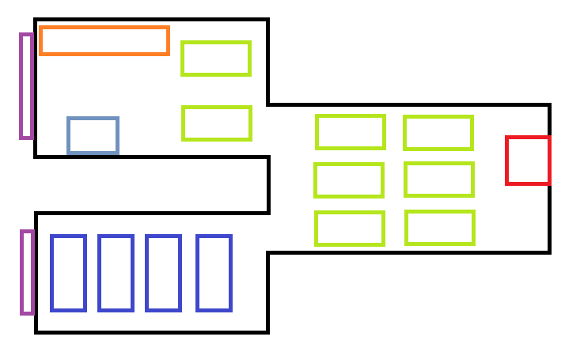

Second floor Layout:

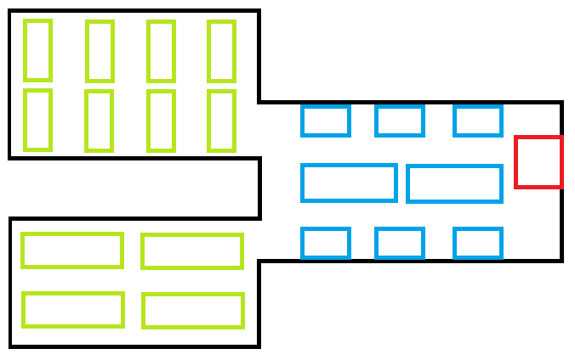

Legends:

Green – shelves

Light blue – cooling units

Red – lift

Dark blue – cashiers

Orange – trolley bay

Purple – doors

|  |  |  |  |  |  |  |
| --- | --- | --- | --- | --- | --- | --- |
| No hrs | Activity/tasks | Rayner | Andy | Glenn | Wei Heng | Chun Kiat |
| 2 | Interior textures and ground mesh level 1 | 1 | 1 |  |  |  |
| 2 | Interior textures and ground mesh level 2 |  |  | 1 | 1 | 1 |
| 1 | Bound check for textures and ground mesh | 1 |  | 1 |  | 1 |
| 1 | Create starting position | 1 |  |  |  |  |
| 4 | Do stairs and lift |  | 1 |  | 1 |  |
| 2 | Add large objects to level1 | 1 | 1 |  |  |  |
| 2 | Add large objects to level2 |  |  | 1 | 1 | 1 |
| 7 | Bound checks for large objects | 1 | 1 | 1 | 1 | 1 |
| 6 | Add small objects | 1 | 1 | 1 | 1 | 1 |
|  | Total | 20 | 20 | 19 | 20 | 19 |